November 30th, 2008
Hi
Not too much to write about. Started exercise again – pool closed now so all in the gym. Exercise was a bit difficult having had so many days off. It is surprising how quickly physical conditioning can fall off. Exercise is something like eating – you need it every day. The gym now has only two treadmills instead of four as two have broken down to the extent that they are not being repaired. As the treadmills are the most popular pieces of equipment, the gym has set up a waiting list for use at peak times and limited the time on the machine to 30 minutes. BTW, when I looked around the gym at the Ritz-Carlton Hotel in Jakarta, I saw that their treadmills have a TV screen built into them.
On Friday, I did no exercise – a rest day, prior to the first hike/run for the season. A later start this year due to time lost going to Indonesia. The run was better than I expected. I was expecting about 2 hours, but it turned out to be 1 hr 53 min, only 3 minutes slower than my best. However, this time was helped by the almost perfect conditions of 18⁰C and humidity that was so low, there was hardly any sweat on my body or clothes. Temperatures had dropped substantially in the past week. Yesterday morning, they actually went down to 3⁰C in an area close to the border.
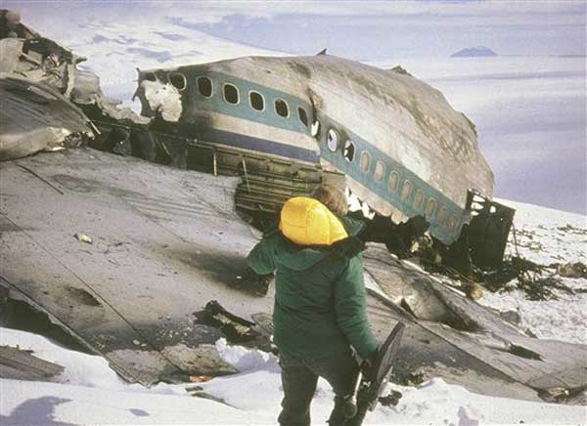
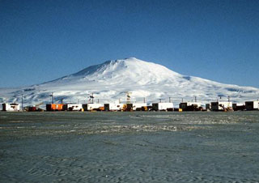
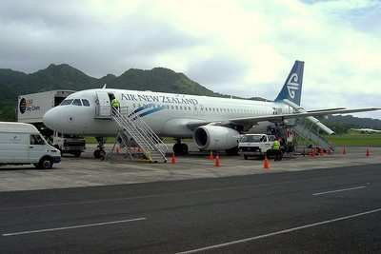
Did you here that an Air New Zealand Airbus A320 crashed the other day into the Mediterranean Sea off the coast of France, following a test run, killing the seven crew members on board. The plane had been leased to a German airline for a couple of years, and was undergoing trials before returning to NZ. This crash came on the 29th anniversary of the disaster in Antarctica, when an Air NZ DC-10 taking passengers on tourist overflights to view the continent crashed into a cloud-covered Mt Erebus [picture below]. This was due to faulty coordinates in the navigation computer that had been corrected without the crew or the flight controllers being told and by the pilots who flew into cloud at a low altitude. All 237 on board were killed. Hillary himself had been the commentator on earlier flights. This disaster ended the overflights, which both Air NZ and Qantas had been carrying out.
The Rugby tours by NZ and Australia to the northern hemisphere ended yesterday. The ABs easily defeated England 32-6 to get a grand slam of victories in all four of their matches. Wales beat Australia 21-18. Earlier in the week, the ABs had an audience with the Queen; during that, Prince Philip commented to the AB captain that NZ would have no trouble beating England. In Dubai, the first iRB Sevens tournament for the season opened. England won the Cup after defeating South Africa in the final and NZ in a semi-final.
From time to time, I have been getting e-mails from Leonie’s wedding photographer. The final deadline for getting photographs is today. So what I did was to copy some of the approximately 1000 pictures on the website. But these were not proper photo-format pictures; I could only press the ‘Print screen’ button to get a copy of the screen, paste the picture into a word file and then crop the picture to remove the page around the picture. Also of course, the pictures have the photographers name printed on them. Still, not too bad.
That’s about it for now.

Cheers

